This document describes high-level overview of the application that will be built during the DRP - Java Stream training.

# Application Layers

Web Application

(Spring MVC,JEE)

Frontend Layer

(AngularJS)

Rest Service

Spring/Jersey Rest)

Business Layer( Java)

Data Access Objects Layer (JDBC /Hibernate)

Database(Oracle/MySQL)

# Dependencies

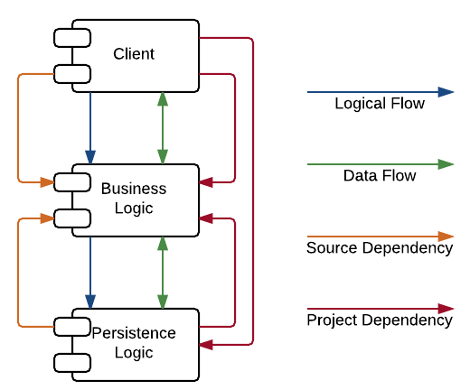

Application will consist of below listed layers

# Layer

1. Database
2. Data Access
3. Business
4. Frontend Design
5. Spring MVC
   1. Model
   2. View
   3. Controller
6. Rest Service
7. AngularJS Client

## Detailed Component Diagram

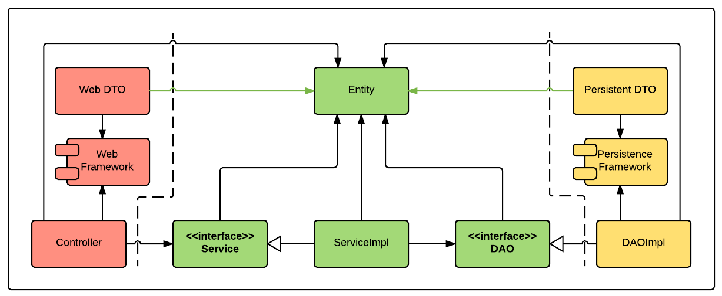

# Detailed List of artifacts

* Database -During Oracle Training
  + Tables
  + Stored procedures
  + Views
* Data Access -During JDBC and Hibernate Training
  + Interfaces
  + DTO
  + Implementations
  + ORM- Hibernate
  + Unit Test
* Business – During Core Java Training
  + Business Objects(Beans)
  + Service interface
  + Service Implementations
  + Business Exceptions
  + Unit Test
* Frontend Design -During Web Development Part 1
  + Html Pages
  + CSS Pages for style and layout
  + JavaScript module for Validations
* Spring MVC -During Spring Training
  + Model
    - Custom View Objects or Business Objects
  + View
    - JSP/Html pages modified from Frontend design phase
  + Controller
    - Controller with routing and connecting with service implementation
  + Unit Test
* Rest Service -During Spring Rest Training
  + Rest service based on Spring Rest
  + Unit Test
* Angular Client -During Web Development Part 3
  + Modify the frontend design phase pages to angular application with angular based routing, forms, validations and services and actions. Use the Rest service made in previous module for business operations

Note:

* Use Maven for dependency management
* Use SVN for repository Management